Lab 05: Network Configuration and Troubleshooting

Overview:
The Netplan utility is a network configuration tool used in Ubuntu to manage network settings through YAML files. It allows users to define network interfaces, IP addresses, routes, and DNS settings in a structured format. Netplan simplifies the process of configuring network settings by providing a clear and concise way to manage both static and dynamic IP configurations. Once the configuration is defined, it can be applied using the netplan apply command, which activates the new settings without requiring a reboot.

Commands Used in This Lab
Command Purpose
ip -br a Displays brief information about network interfaces and their IP addresses.
ping -c 4 8.8.8.8 Tests Internet connectivity by sending 4 ICMP echo requests to Google DNS.
nslookup microsoft.com Performs a DNS lookup to resolve the IP address of microsoft.com.
sudo iftop Monitors real-time network bandwidth usage by interface.
netplan apply Applies changes made to the netplan configuration file.

Procedure:

Part 0: Mandatory VM Snapshots

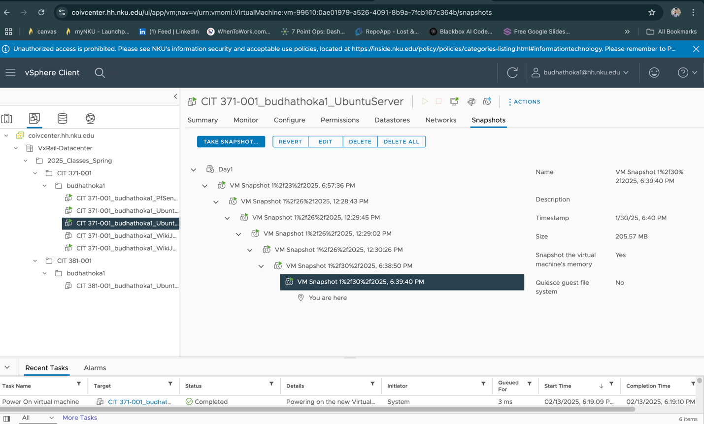

Part 1: Preparing your Lab Environment
→Sign into COIVcenter and power on your PfSense VM.
→Wait a few minutes for it to boot.
→ Power on your Ubuntu client VM (not the server).
→Log in to the Ubuntu client as the student user with the password Student371!.
→ Optionally, test network connectivity by running:
→ ping 8.8.8.8

Part 2: Network Configuration – Netplan
→ Release the DHCP lease: sudo dhclient -r
→ Identify the network interface: ip -br a
→ Switch to the root user: sudo -i
→Create a backup of the netplan configuration file: cp /etc/netplan/01-netcfg.yaml /root/01-netcfg.yaml.bak
→Open the netplan configuration file in nano: nano /etc/netplan/01-netcfg.yaml
→ Configure the file with the following settings:
-network:
- version: 2
-renderer: NetworkManager
- ethernets:
- ens33: # Replace with your interface name
- dhcp4: false
- addresses:
- - 192.168.1.210/24
- routes:
- to: 0.0.0.0/0
-via: 192.168.1.1
- nameservers:
- addresses:
- 192.168.1.1
→ Apply the netplan configuration: netplan apply
→ Reboot the Ubuntu client: reboot
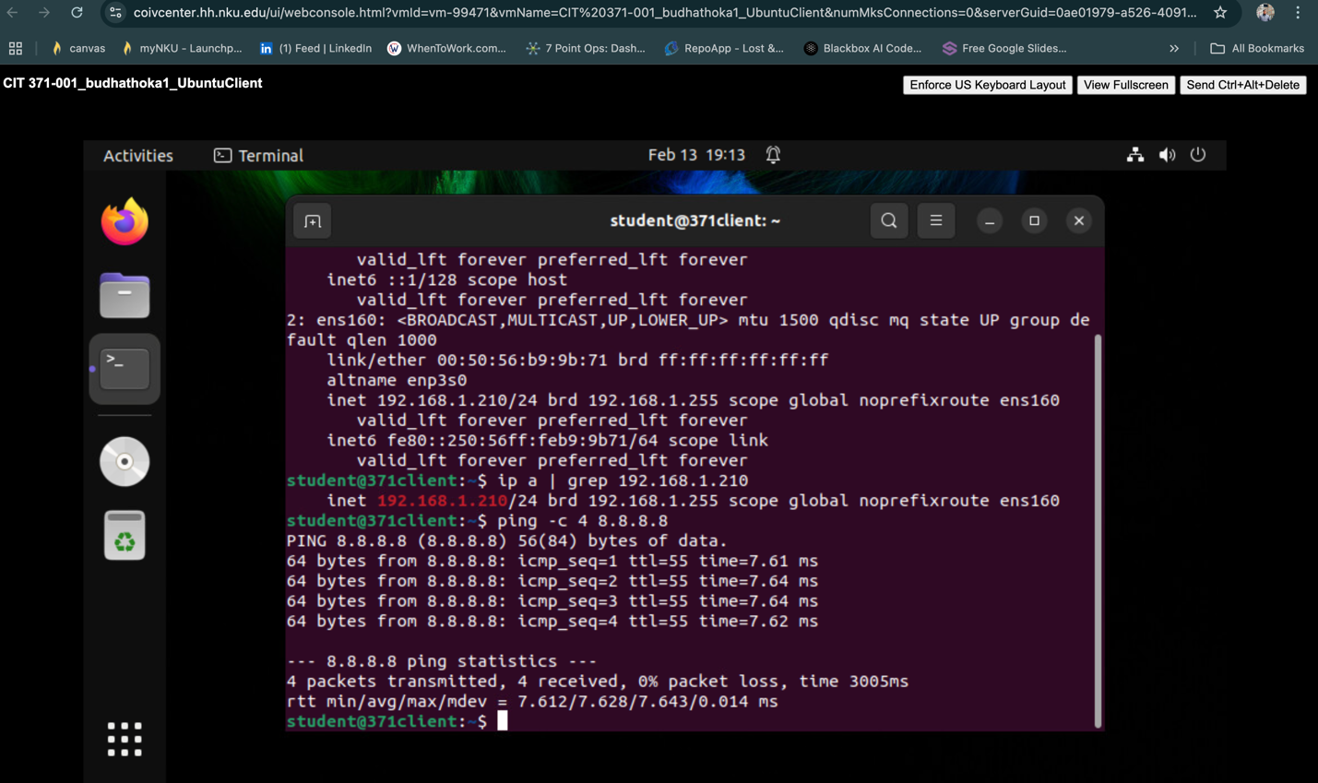
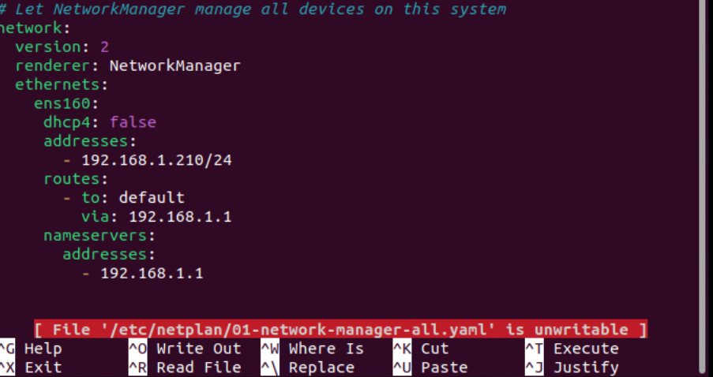

Part 3: Network Troubleshooting - Commands
→ Verify Network Status:
ip -br a
→ Confirm the static IP address
ip addr show ens33
→ Ping Google’s DNS server:
ping -c 4 8.8.8.8
→ Perform a DNS lookup for
nslookup microsoft.com
→ install iftop
sudo apt install iftop
→ Run iftop
sudo iftop
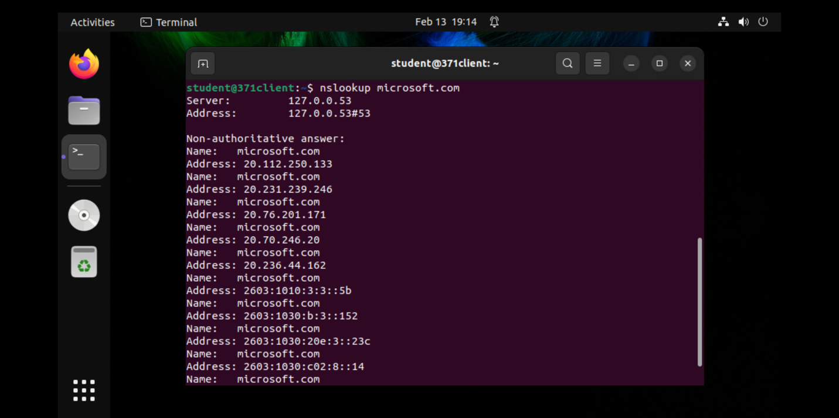

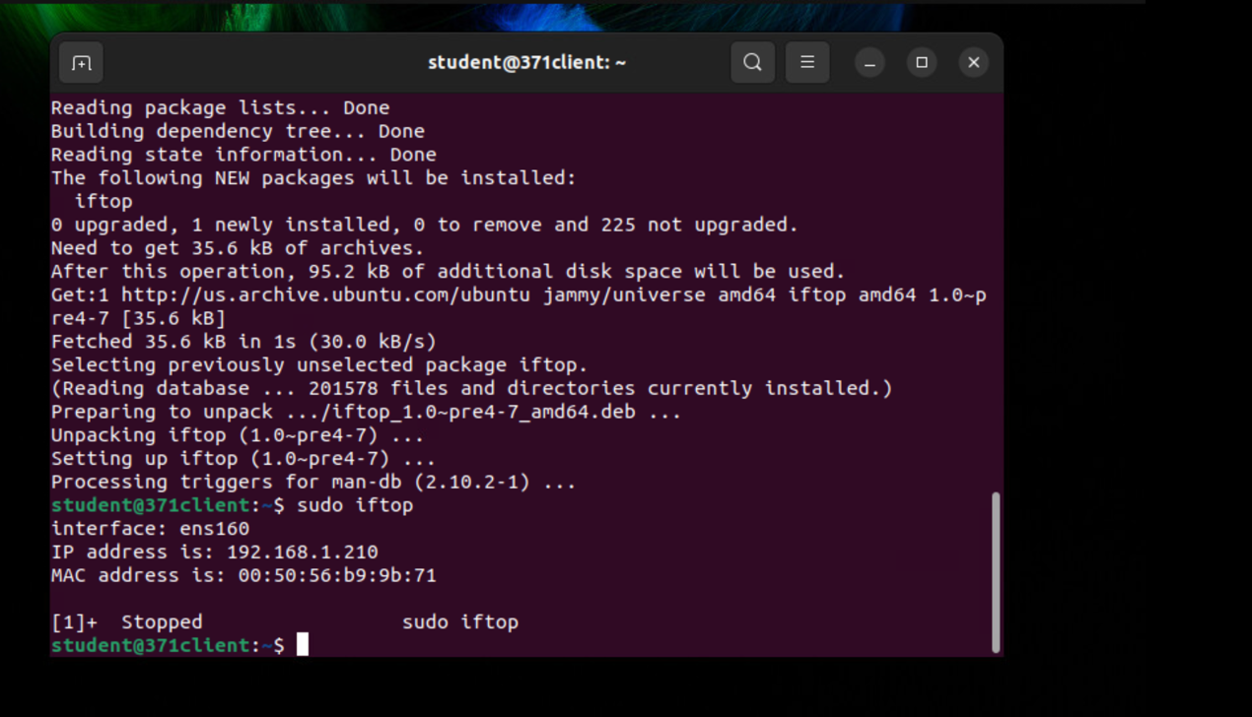
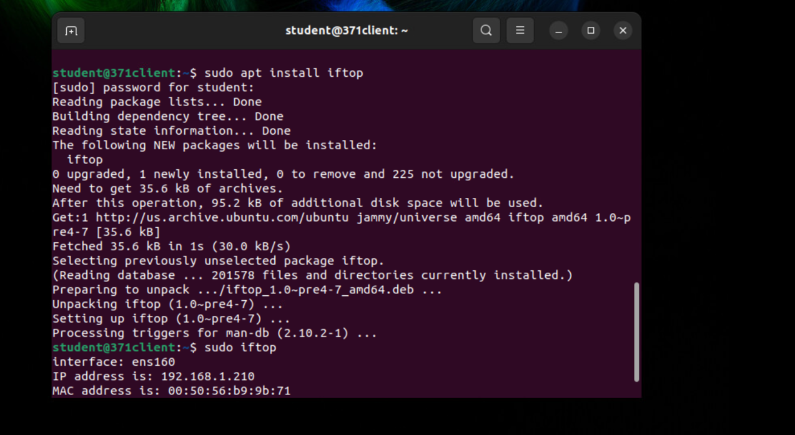

Reference:
https://www.cliffsnotes.com/study-notes/21300218
https://www.iitk.ac.in/LDP/LDP/nag2/nag2.pdf

